**QVX Writer Workflow**

In this KNIME Workflow, a data table is created by the Excel Reader node. The Column Filter node removes some of the columns. Our QVX Writer saves this modified table into a QVX file.

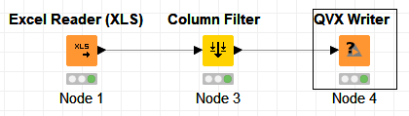

The generated QVX file can be loaded into QlikView as a data table.

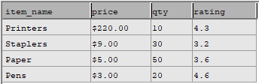

**QVX Writer**

The QVX Writer Converts a KNIME data table into a QVX file. Based on the data table’s information, the Writer can determine the data format that should be used for the QVX file.

To use the node, select an output location for the QVX file. Optionally, modify the default QVX data format by using the “Field Attributes” tab.

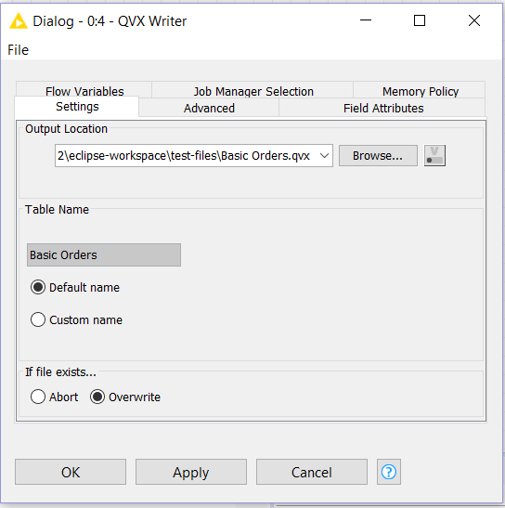



QVX Reader and QVX Writer Nodes

Monica Sangam

Matthew Belanger

KNIME is a data analytics platform. The user can load a dataset into KNIME, manipulate the data, and then produce a report (such as a chart or graph).

QlikView is a business discovery platform that can be used to analyze data. QlikView can read data from QVX files.

Our goal was to create a KNIME node that could load QVX data files. Our other goal was to create a node that could convert KNIME data into a QVX file.

QVX files can